***\*\* RESTAURANT MANAGEMENT \*\****

M.BHANU TEJ

E0320024

ABOUT RESTAURANT-

**“INDIAN ACCENT” the title of the restaurants just gives the original flavour and taste of the food served in it . The chefs over their symbolise the taste with their overwhelming heart and serve the guests.**

1. **The major part of this web page includes different staples of food available in the restaurant.**
2. **Next displayed a new seating as the arabic style “MANDI” seating the new era begined over years and we are late to it .**
3. **The coding of this web page had a major part of routine links to the display in menu process .**
4. **We have placed 4 different food styles in the menu (veg,non veg,desserts,soft drinks)**
5. **A simple and cute webpage gave me a good experience and I've learned a lot ,enjoyed doing this.**

**CODE -**

**App.componet.html**

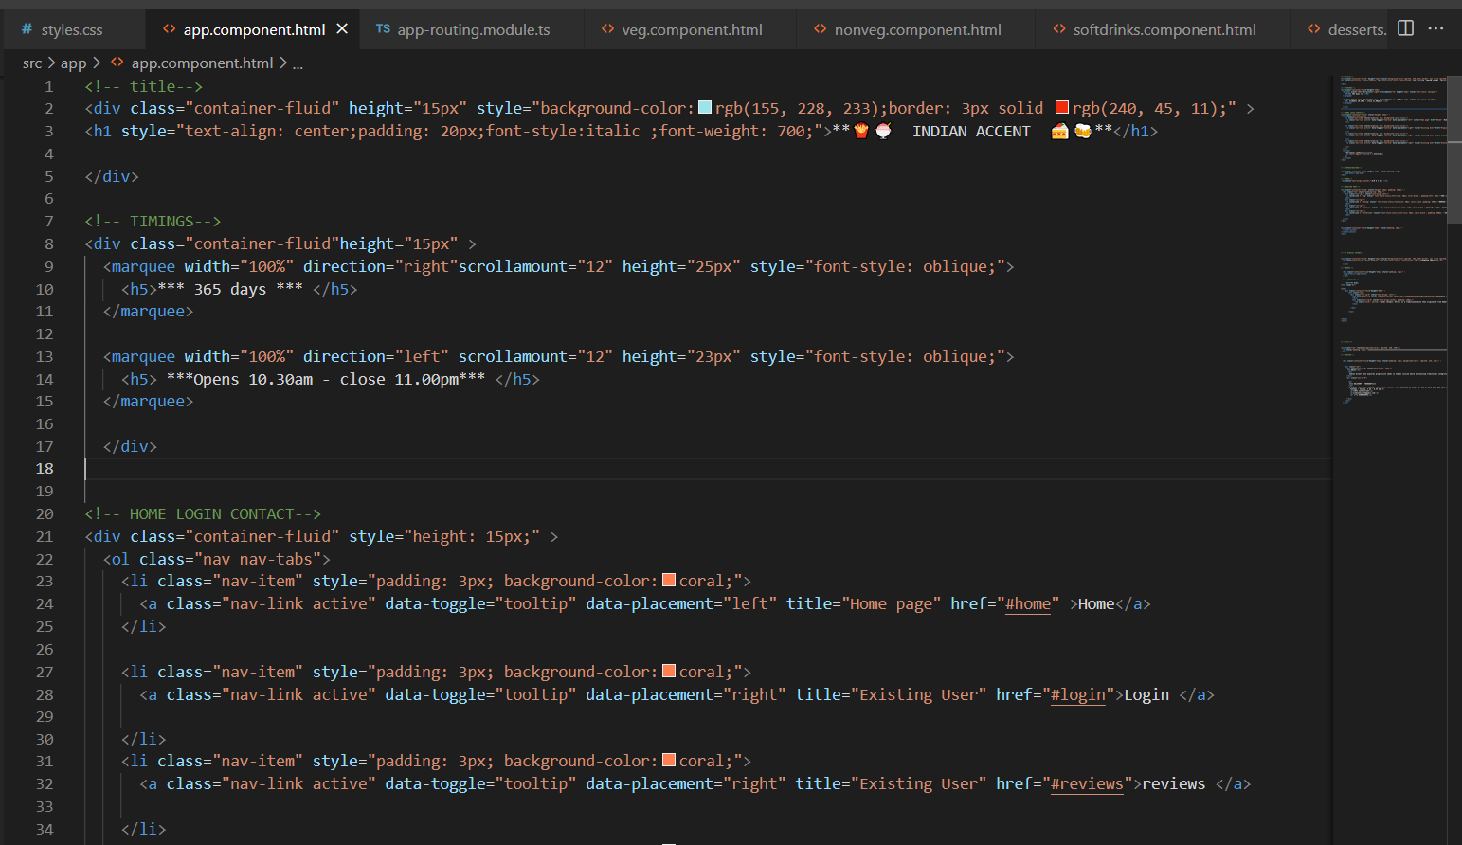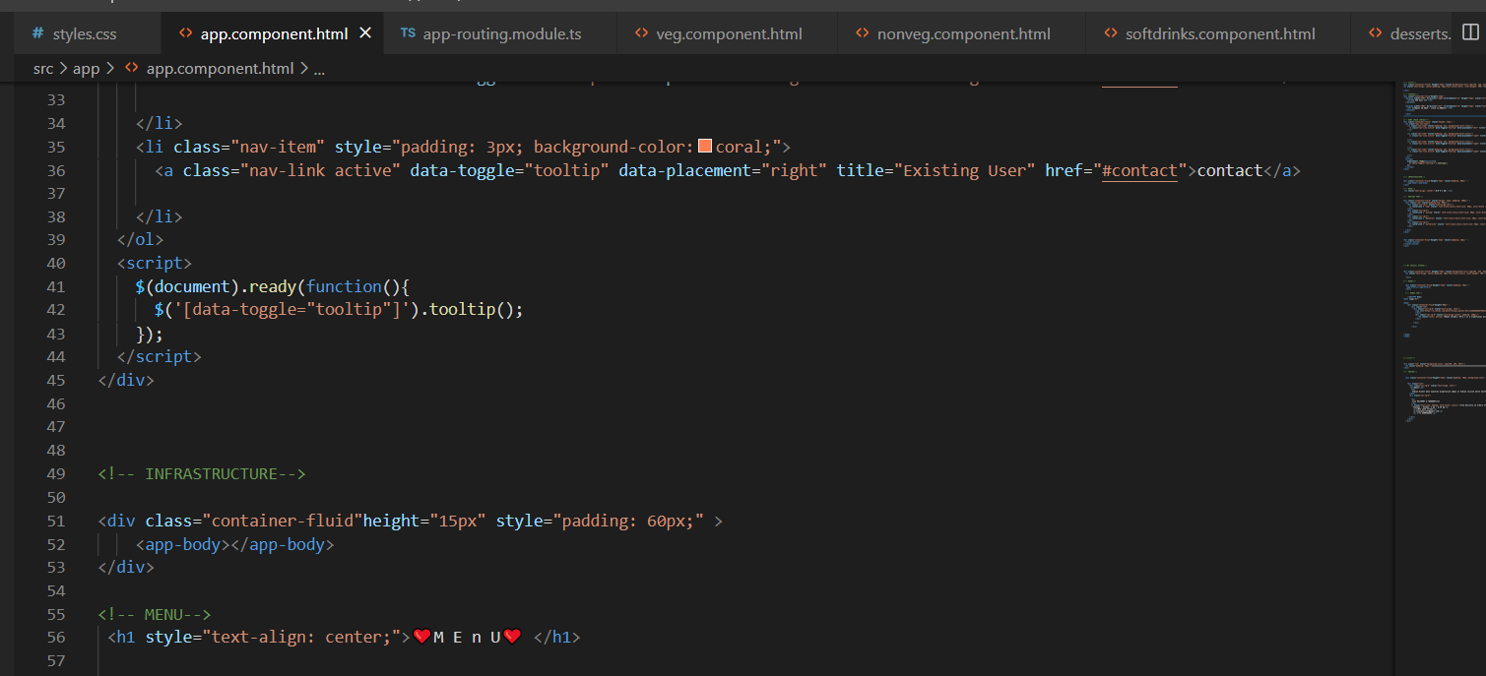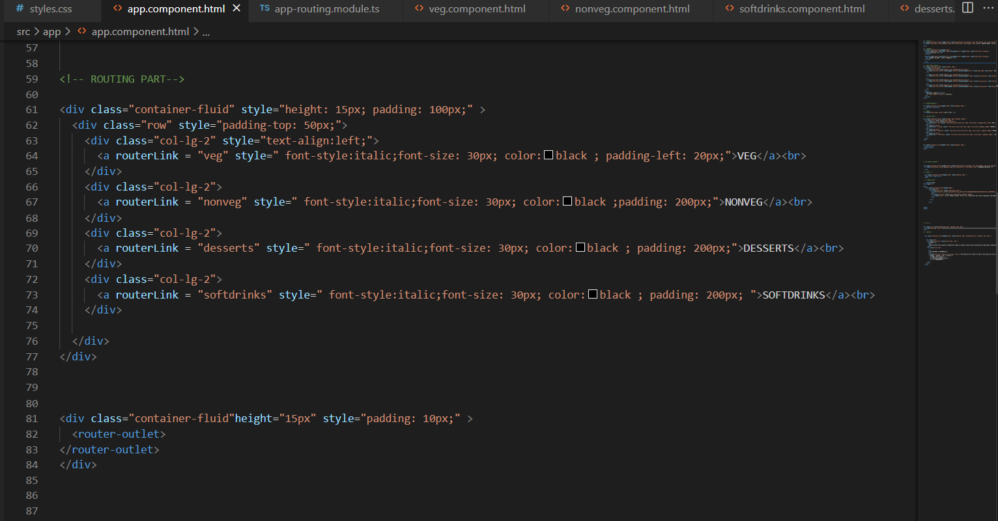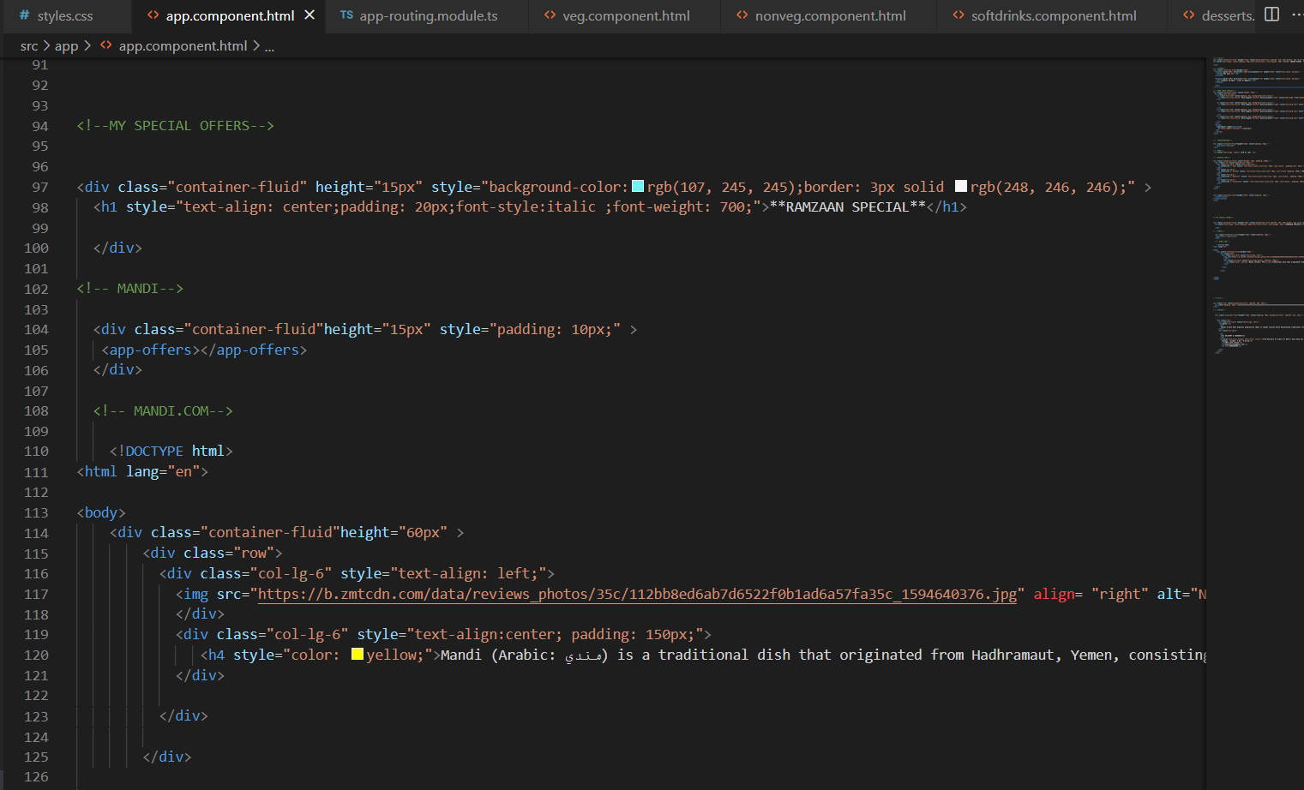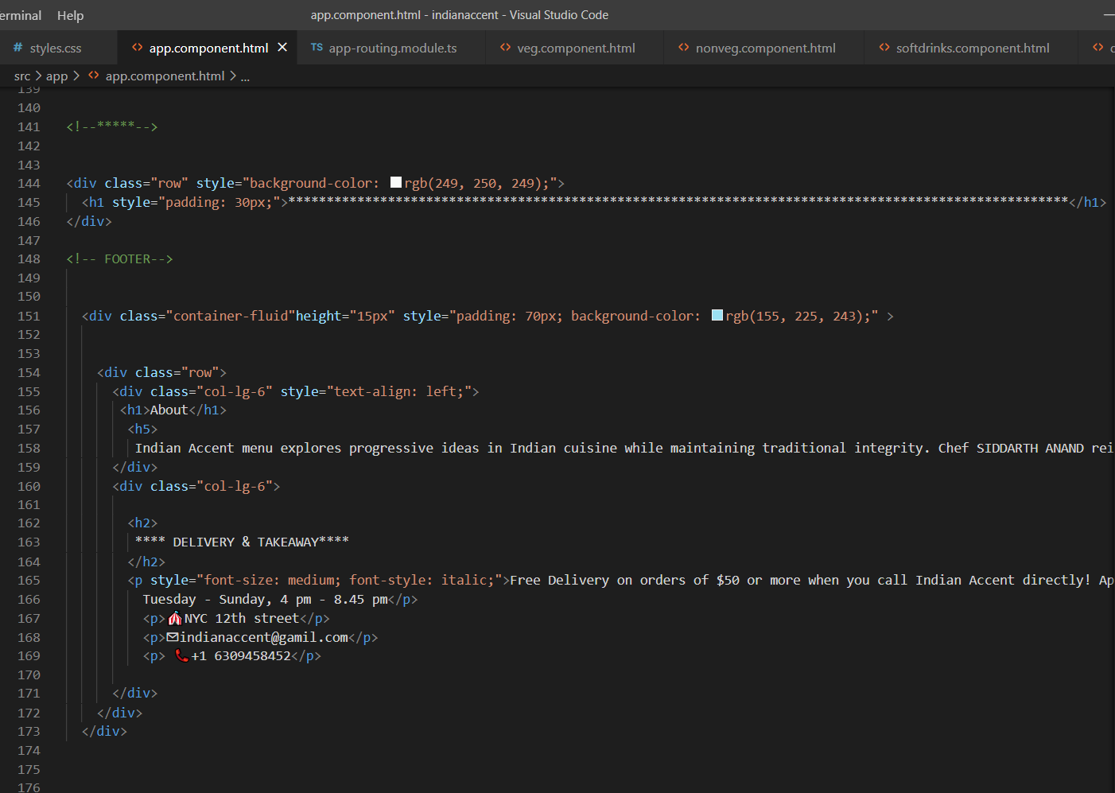

**App.ts routing**

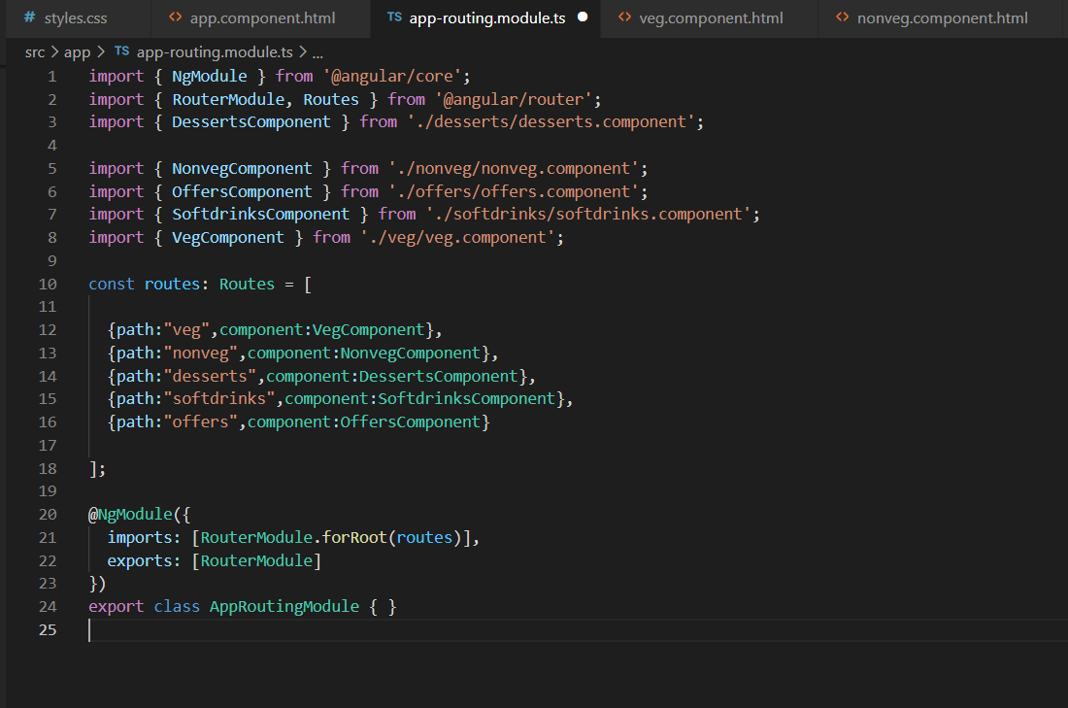

**Body.html**

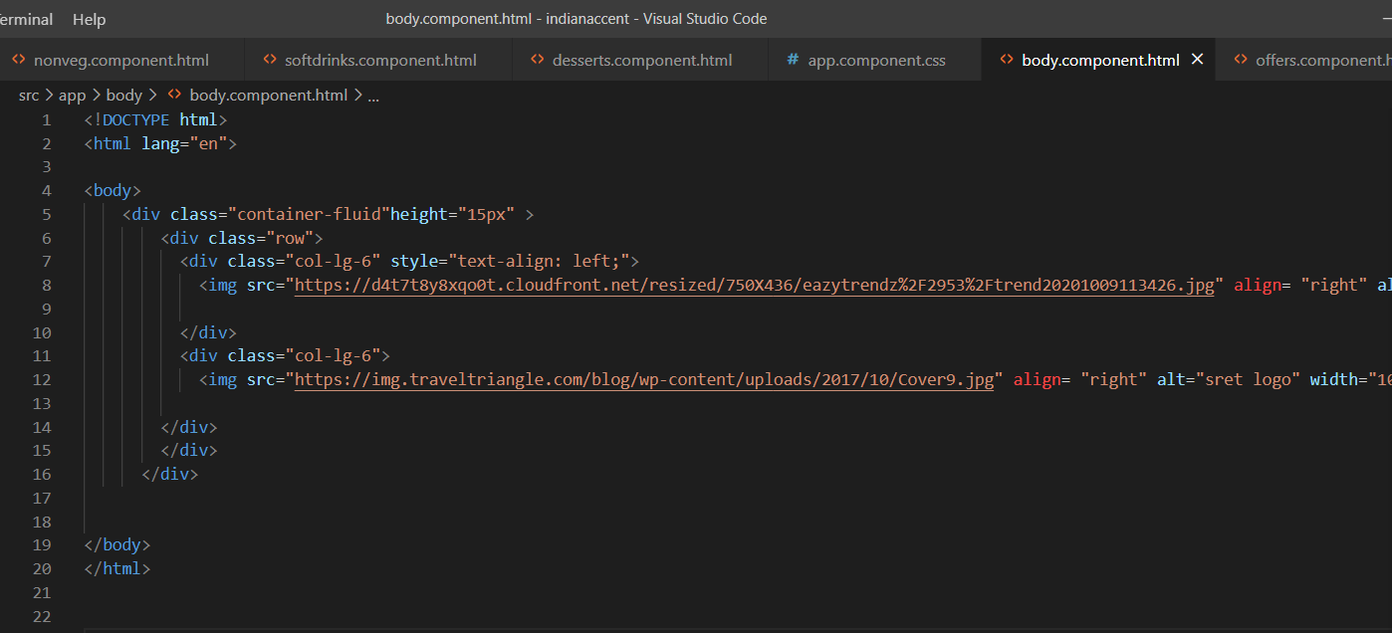

**Veg.html nonveg.html desserts.html softdrinks.html**

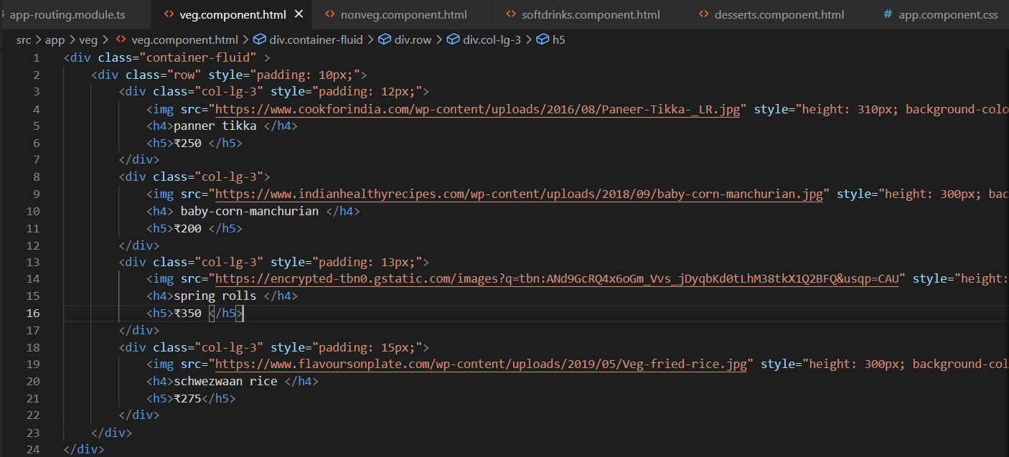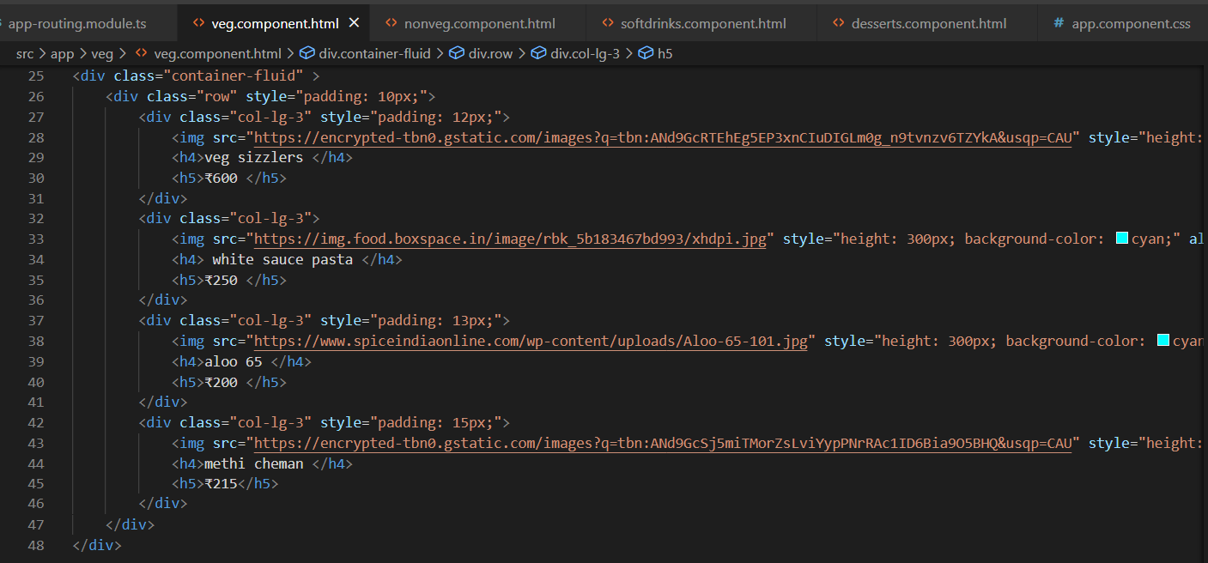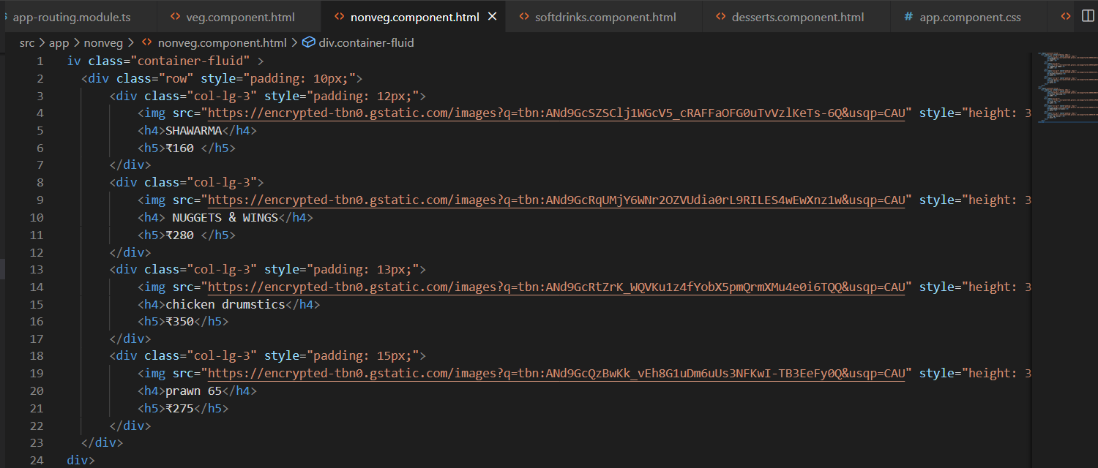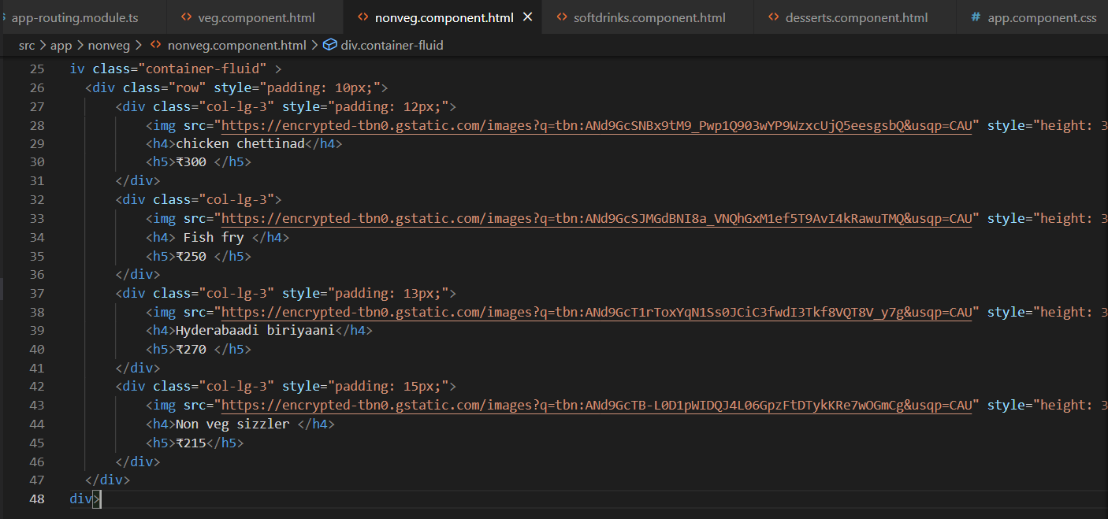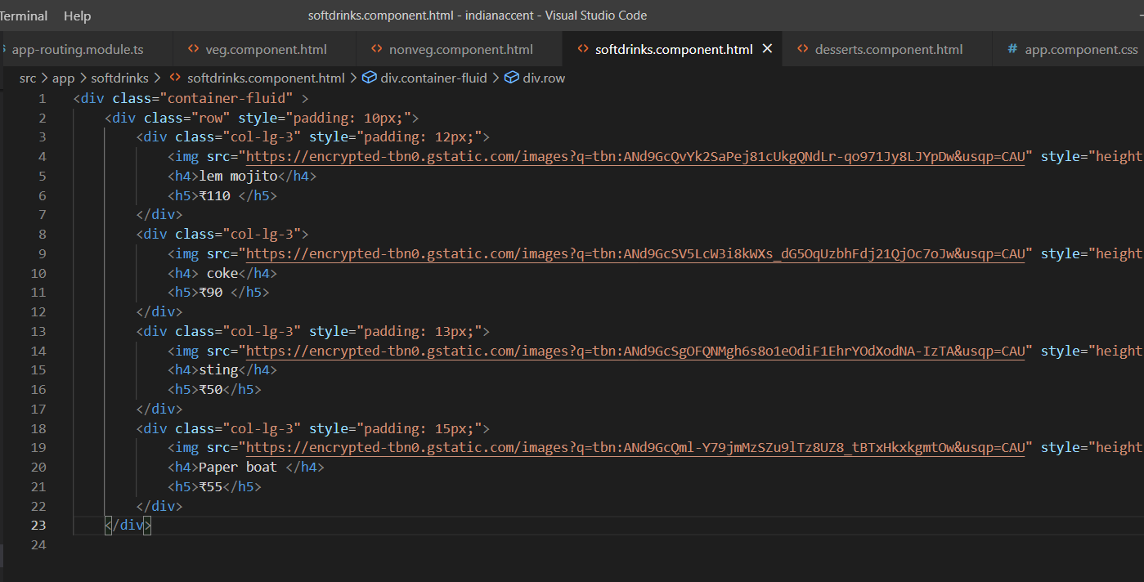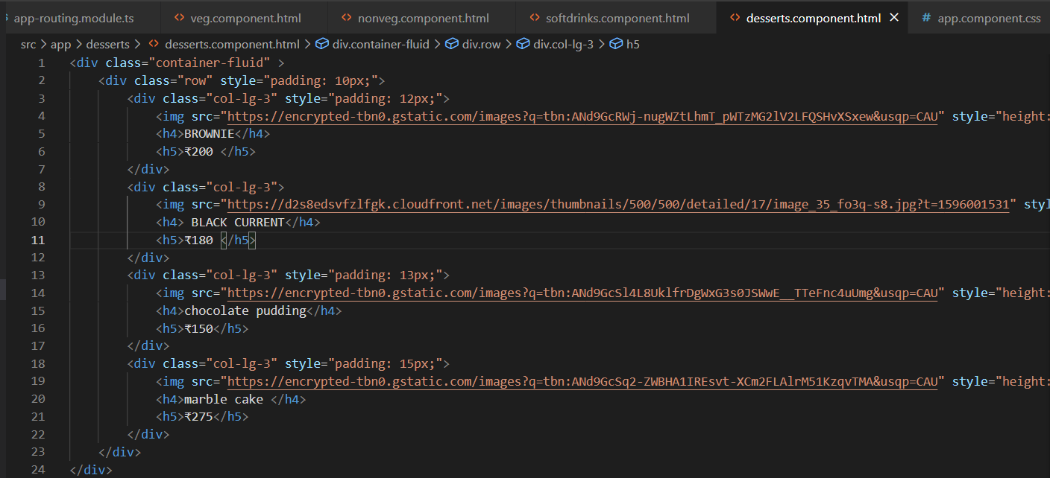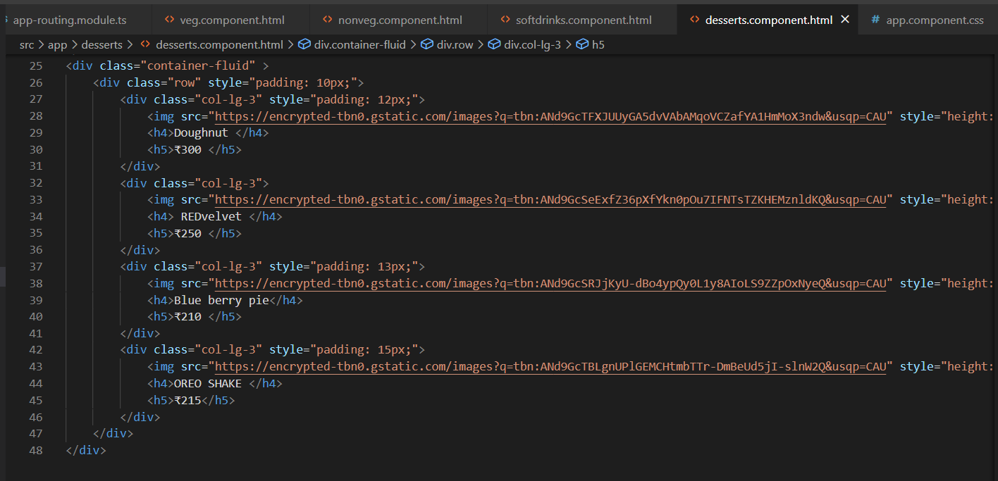

**Offers.html**

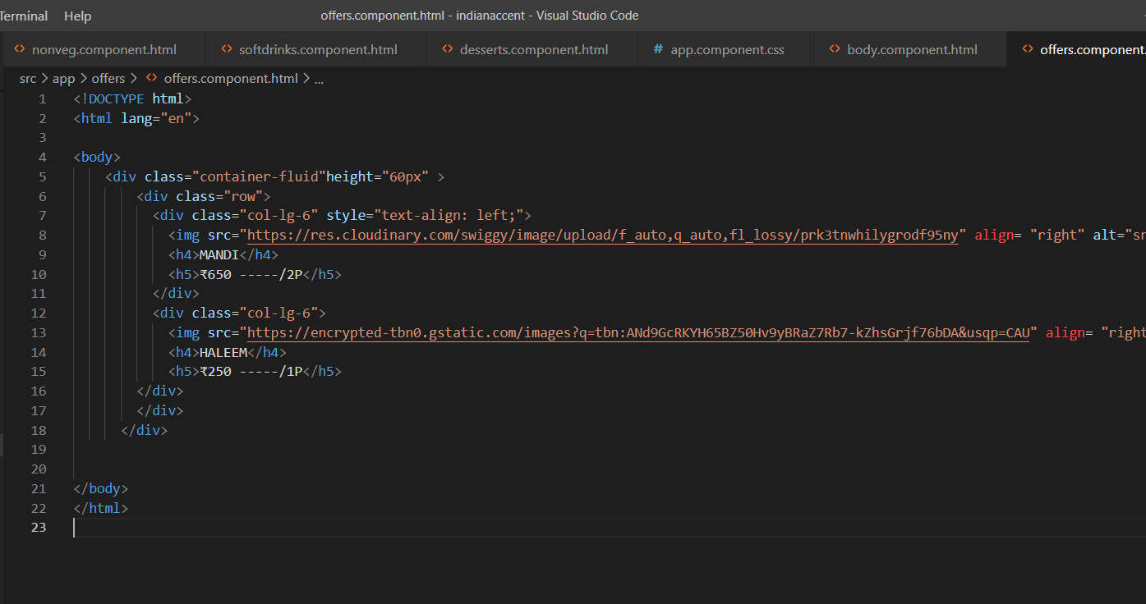

**OUTPUT OF THE WEBPAGE-**

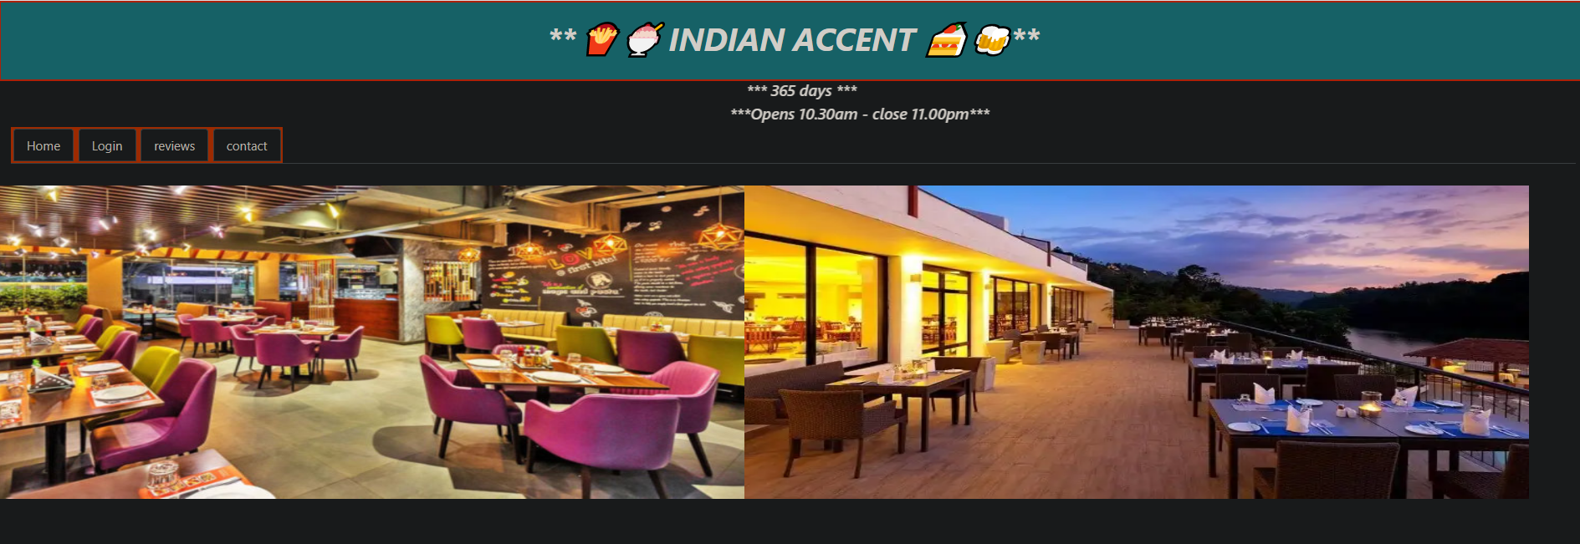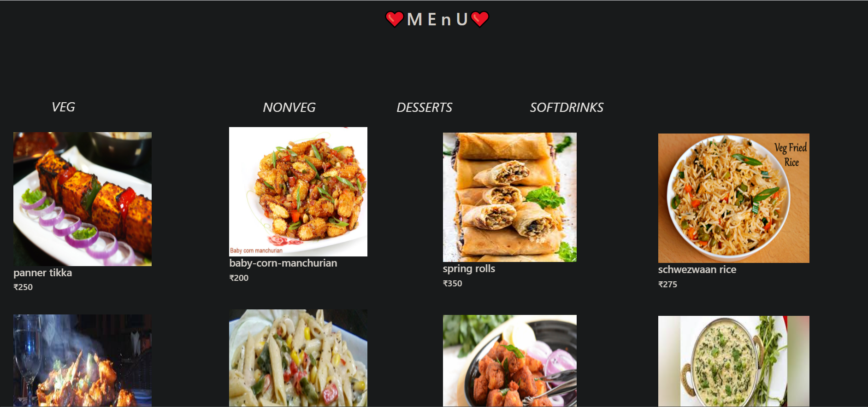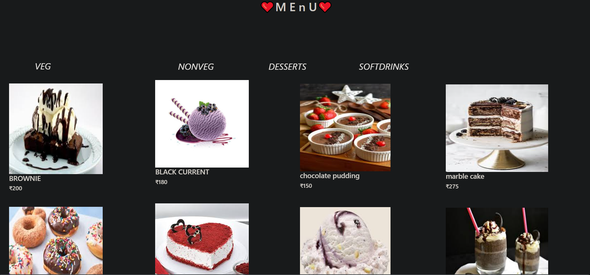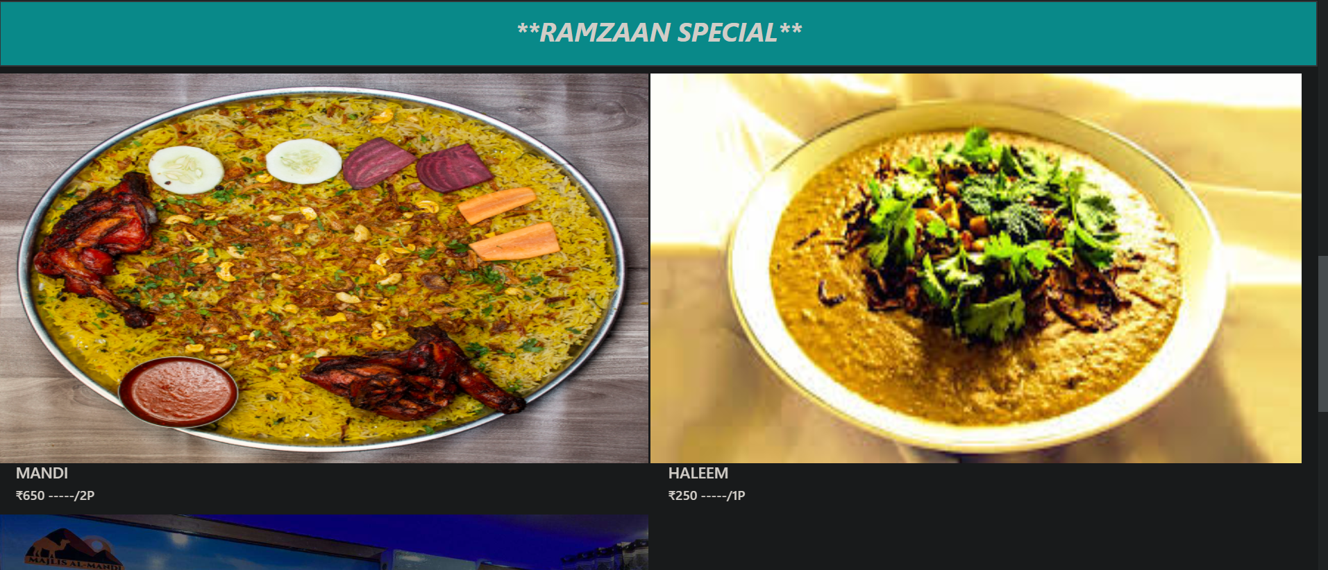

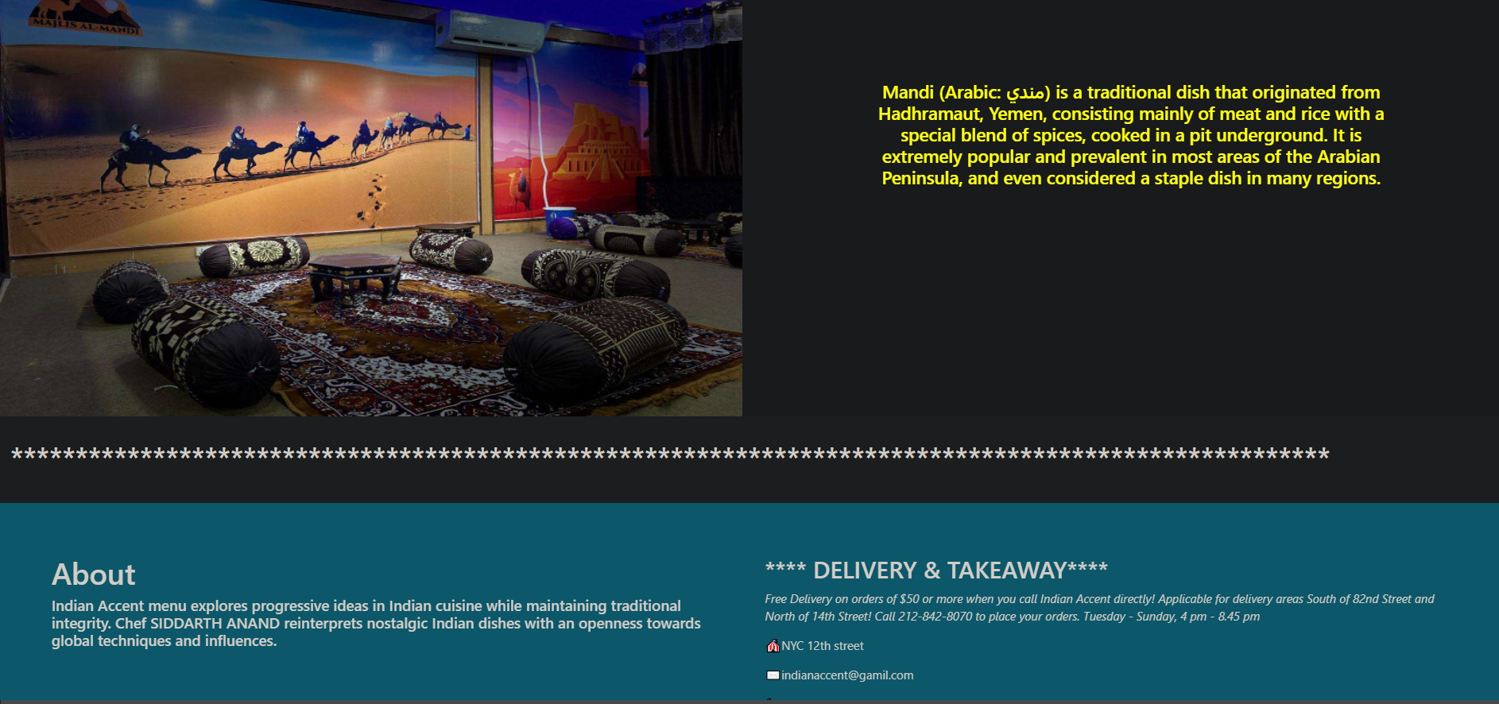

**“ THANK YOU❤️**

**LOVED TO DO THIS PROJECT” ❤️**